**Project 1: Chemical Oscillations Beau G.**

**Date: 4/15/2018**

**Abstract**

The goal of this project was to solve a set of two coupled first order differential equations that are displaying a system of two reactants interacting. The equations contain a set amount of two reactants and therefore leading to the other reactants reacting to each other. In order to achieve this goal it would be necessary to create a numerical method to solve the differentials and obtain the data showing the behavior of the system.

**Introduction**

My numerical solution to the problem consisted of creating a method as a function of time taking in the current X and Y values and solving for the derivative of both and returning that data. That data was then put through a 4th Order Runge-Kutta solver in order to perform the integration. Once the data for the x position values and y position values were all calculated, I was able use that information to create plots of X vs. Y in order to analyze behavior from the inputted values. I created the first function to take in a value for X, Y, A, B, and period, so I could input different values and analyze the behaviors. From there I modified the first function in a way so that it takes in an A and B value as an argument and therefore determines the X and Y values from the A and B. This was a necessary adaptation to answer later questions presented where A and B determined X and Y. Once my two functions were established and working all that had to be done was testing different values and analyzing the behaviors. To start our analysis, it was necessary to find the steady state solutions to the two equations by setting each equal to zero. The process is shown in the following short proof.

$\frac{dX}{dt}=A-\left(B+1\right)X+X^{2}Y$ (1)

$\frac{dY}{dt}=BX-X^{2}Y$ (2)

Setting Equation (1) equal to zero and X=0 to find the steady state we see directly that X = A

Setting Equation (2) equal to zero and X=A we can use simple algebra to solve, you get Y = B/A

**Data**

The first task presented was to use set A and B values and perform iterations changing the X and Y values to see if the behavior was independent of the X and Y values. The following three plots are from one iteration of X and Y values with A and B being set to 1 and 2 respectively.

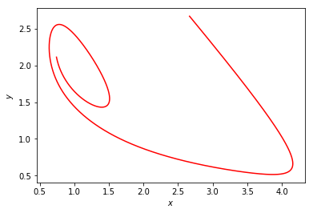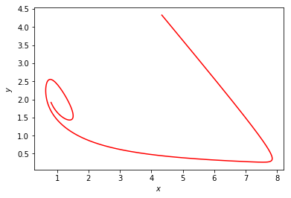Plot 1: X,Y = 2.67 ; A,B = 1,2 Plot 2: X,Y = 4.34 ; A,B = 1,2

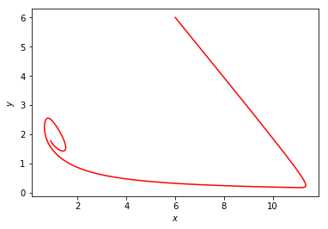 Plot 3: X,Y = 6.0 ; A,B = 1,2

From the plots it is easy to see that changing the values of X and Y has no effect on the long term behavior of the system therefore X and Y are independent of A and B. This process was done with two more iterations of different set A and B values as well as different iterations of X and Y values to test further the relationship between the two and all the cases came back with the same result.

The second task was to use set X and Y values, setting them equal to the steady state solutions shown earlier, except for a slight change in X of +0.001 to keep it very near steady state values. Doing this allows for using iterations of the second function, inputting different A and B values in order to find states where the oscillations become unstable. The case where the oscillations become unstable is shown by the data not decaying down to a specific point but constantly oscillating in a periodic fashion. The case showing stable behavior is shown when the data decays down to one concise point. The following plots are of a single iteration of values for A and B. The iterations were done holding A constant and using different values for B and observing the relationship between the two.

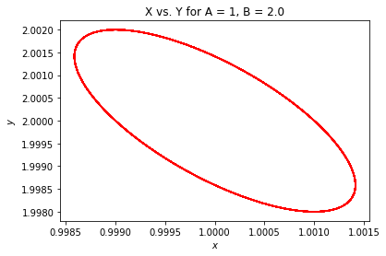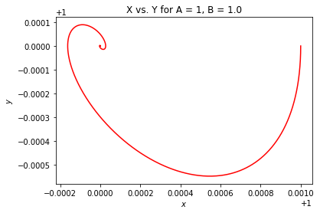Plot 1: X,Y = A+0.001, B/A ; A,B = 1,1 Plot 2: X,Y = A+0.001, B/A ; A,B = 1,2

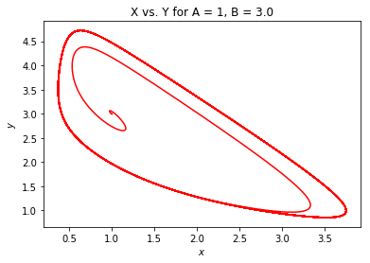 Plot 3: X,Y = A+0.001, B/A ; A,B = 1,3

From the plots it is easy to tell that Plot 1 and Plot 3 decay down to a point where as Plot 2 continues in a oscillatory fashion showing no decay. Therefore we can conclude that Plot 2 is unstable where as the other two plots would be stable. This process was done in two more iterations using different ranges of values for A and B and from observing the other plots you can tell there is a pattern in obtaining an unstable data set. It turns out that if B = $A^{2}+1$ then the set will result in unstable behavior and this was found to agree with all the other iterations.

**Conclusion**

From running different experiments of the chemical oscillator we are able to state a couple of facts proven to be true from our findings. The first being that if A and B are fixed values, no matter the value of X or Y the system will have a consistent behavior. Hence we can say that A and B are independent of X and Y when it comes to the behavior of the oscillator. The second fact being that if we keep X and Y very close to steady state values (based on the values of A and B) and iterating through values of A and B, we can find situations where the system will become unstable. The major piece pulled from this fact being that if we set B = $A^{2}+1$ we are guaranteed unstable behavior, otherwise the behavior with be stable.